# 

# **Department of Computer Science and Engineering Islamic University of Technology (IUT)** A subsidiary organ of OIC

# **Lab 02**

# CSE 4616: Wireless Networks Lab

Section: 2A  
Semester: Summer  
Academic Year: 2020-2021

**Questions and Answer:**

**IP Addresses of Hosts:**

1. What is the IP address of **PC1** of the subnetwork **“Network1”**?

Ans: 172.20.29.2

1. What is the default gateway address of **PC1** of the subnetwork **“Network1”**?

Ans: 172.20.29.1

1. What is the IP address of **PC2** of the subnetwork **“Network1”**?

Ans: 172.20.29.3

1. What is the default gateway address of **PC2** of the subnetwork **“Network1”**?

Ans: 172.20.29.1

1. What is the IP address of **PC3** of the subnetwork **“Network2”**?

Ans: 10.10.29.2

1. What is the default gateway address of **PC3** of the subnetwork **“Network2”**?

Ans: 10.10.29.1

1. What is the IP address of **PC4** of the subnetwork **“Network2”**?

Ans: 10.10.29.3

1. What is the default gateway address of **PC4** of the subnetwork **“Network2”**?

Ans: 10.10.29.1

1. What is the IP address of **PC5** of the subnetwork **“Network3”**?

Ans: 192.168.29.2

1. What is the default gateway address of **PC5** of the subnetwork **“Network3”**?

Ans: 192.168.29.1

1. What is the IP address of **PC6** of the subnetwork **“Network3”**?

Ans: 192.168.29.3

1. What is the default gateway address of **PC6** of the subnetwork **“Network3”**?

Ans: 192.168.29.1

**Screenshot of the routing table of the Routers:**

1. Add a screenshot of the routing table of **Router0** of the subnetwork **“Network1”**.

Ans:

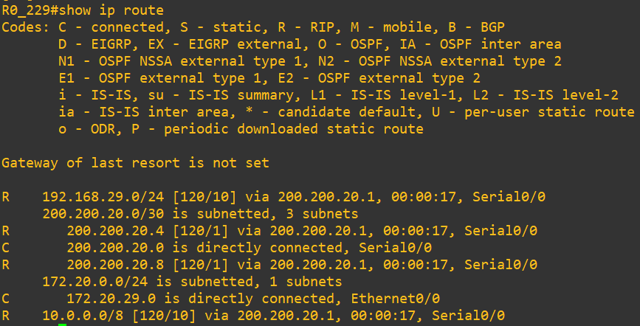

1. Add a screenshot of the routing table of **Router1** of the subnetwork **“Network2”**.

Ans:

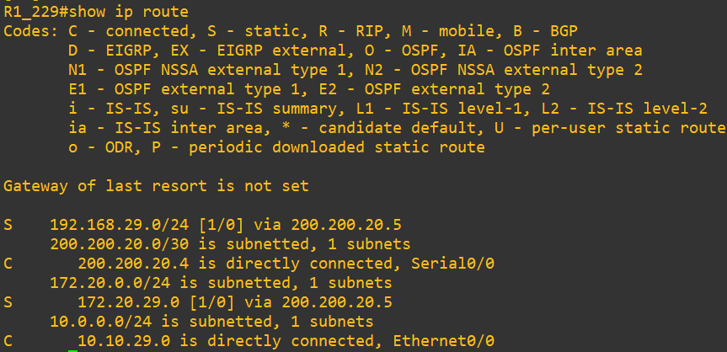

1. Add a screenshot of the routing table of **Router2** of the subnetwork **“Network3”**.

Ans:

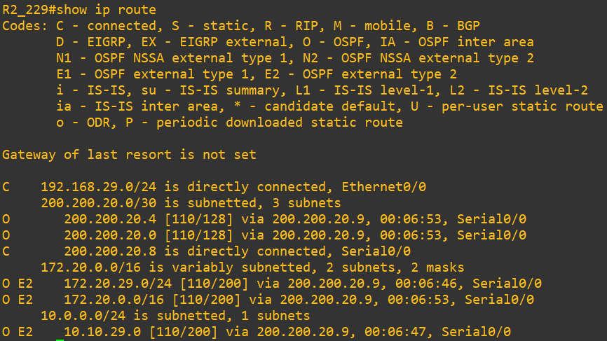

1. Add a screenshot of the routing table of the **Core Router**.

Ans:

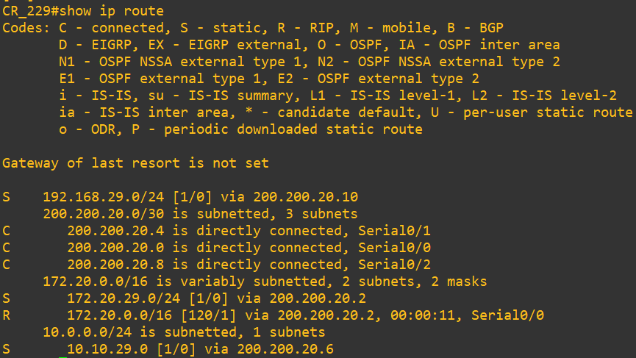

1. Add a screenshot of the complete topology with proper labeling after configuration.

Ans:

